MACH4METAL

metalworking machinery
Transito 21,
6909 DA BABBERICH, Netherlands
Tel. + 31 (0)316 – 247123
Fax. + 31 (0)316 - 247956
info@mach4metal.com
www.mach4metal.com

Bank No : 66.52.13.883
IBAN : NL33 INGB 0665 2138 83
BIC : INGBNL2A

CNC VTL DÖRRIES SDE 300
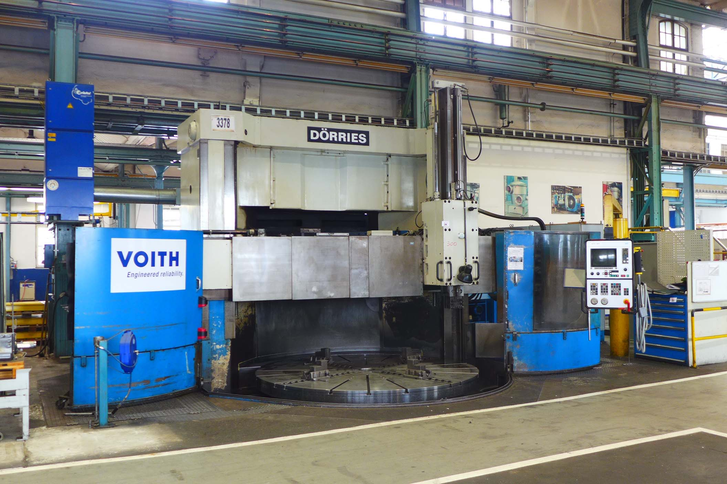
- Make : DÖRRIES Germany
- Typ : SDE 300
- Age : 1979 / 1997
- Serial.No : V107 / 50 751

- Chuck Ø : 3.000
- Max swing Ø : 3.500
- Load on chuck : 25.000

- Height under tool : 2.150
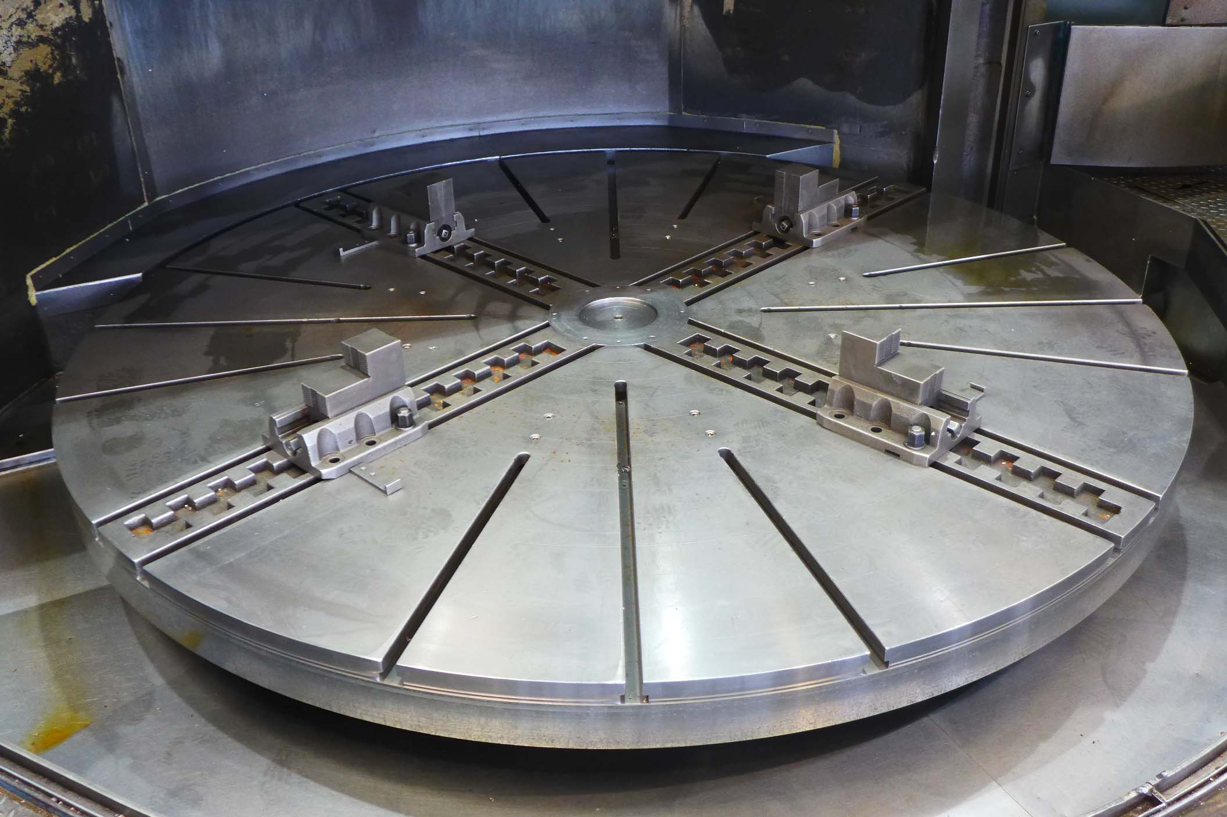
- Height under rail : 2.245
- Adjustment crossrail : 1.750

- RAM travel horizontal : 2.000
- RAM travel vertical : 1.500
- RAM Swivable : 30 / 45°

- Right Ram Hor + Vert : 750 / 1.320
- Ram swivable : 30° / 45°
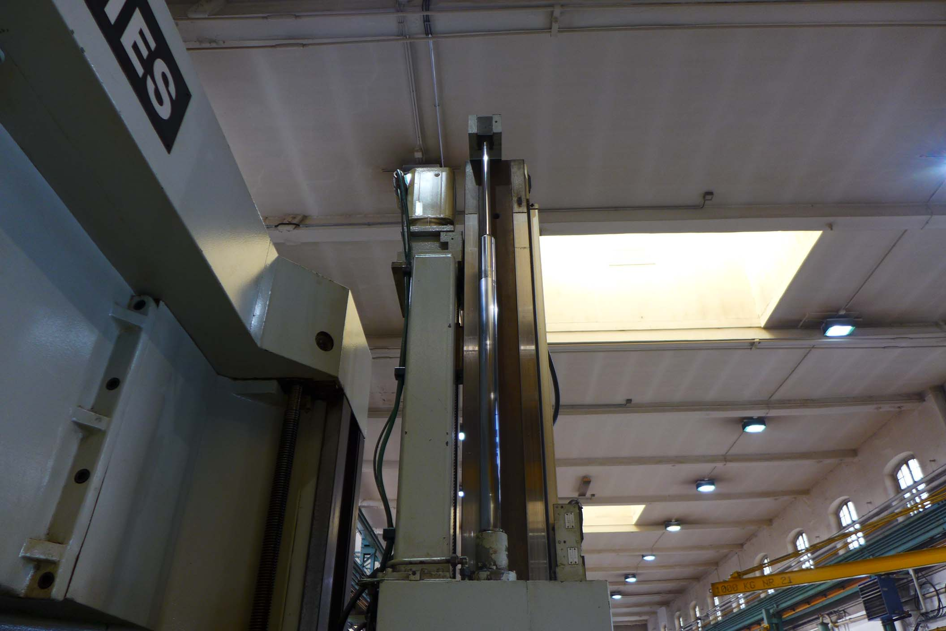
- Table speed : 0,18 – 100 Rpm
- Rapid feeds : 2.000 mm/Min
- Cutting force : 75.000 N

- Dimensions
- Length : 5.810
- Width : 6.300
- Height : 7.010
- Weight : 43.000

- R & D CNC Control MTC S01

Please Note: The above information has been obtained to the best of our ability and belief from, and from the manufacturers where possible. It is given in good faith, but its accuracy can not be guaranteed. Accordingly, it will not form a representation or constitute contractual terms. We advise you to check any vital details

